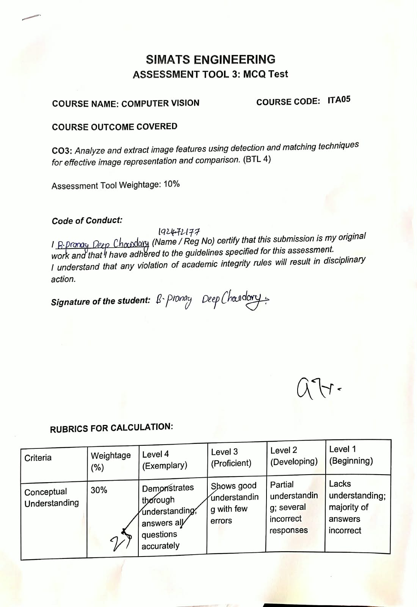
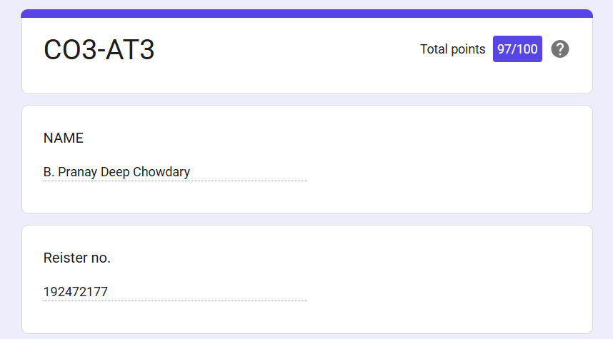

SIMATS ENGINEERING
ASSESSMENT TOOL 3: MCQ Test

COURSE NAME: COMPUTER VISION COURSE CODE: ITA0504
COURSE OUTCOME COVERED

CO3: Analyze and extract image features using detection and matching techniques for effective image representation and comparison. (BTL 4)
Assessment Tool Weightage: 10%

Code of Conduct:

I B. Pranay Deep Chowdary (192472177) (Name / Reg No) certify that this submission is my original work and that I have adhered to the guidelines specified for this assessment.
I understand that any violation of academic integrity rules will result in disciplinary action.

Signature of the student: B. Pranay Deep Chowdary

RUBRICS FOR CALCULATION:

Criteria | Weightage (%) | Level 4 (Exemplary) | Level 3 (Proficient) | Level 2 (Developing) | Level 1 (Beginning)
Conceptual Understanding | 30% | Demonstrates thorough understanding; answers all questions accurately | Shows good understanding with few errors | Partial understanding; several incorrect responses | Lacks understanding; majority of answers incorrect
Accuracy of Answers | 25% | All answers are correct | Most answers are correct with minor mistakes | Some correct answers; frequent errors | Mostly incorrect answers
Application of Knowledge | 20% | Correctly applies concepts to problem-based questions | Applies concepts with minor errors | Limited ability to apply concepts | Unable to apply concepts
Time Management | 15% | Completes quiz well within time efficiently | Completes on time with minor delays | Requires extra time or rushes through questions | Unable to complete within given time
Question Interpretation | 10% | Interprets all questions correctly and responds appropriately | Misinterprets a few questions | Often misinterprets questions | Unable to understand questions

